Week 8: Responsive Web Design and Mobile-First Development
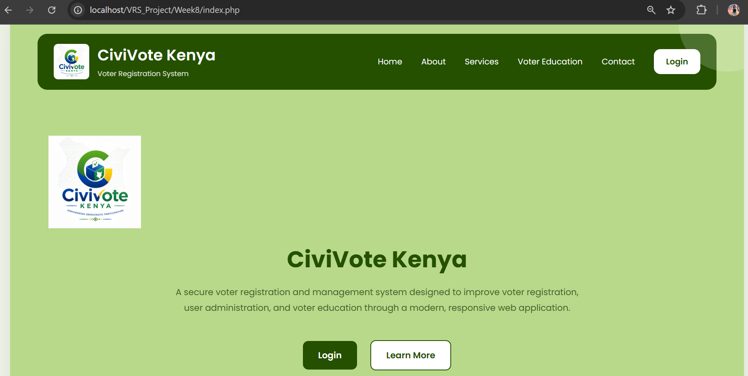
Figure 44: Desktop view of the CiviVote Kenya Home page.

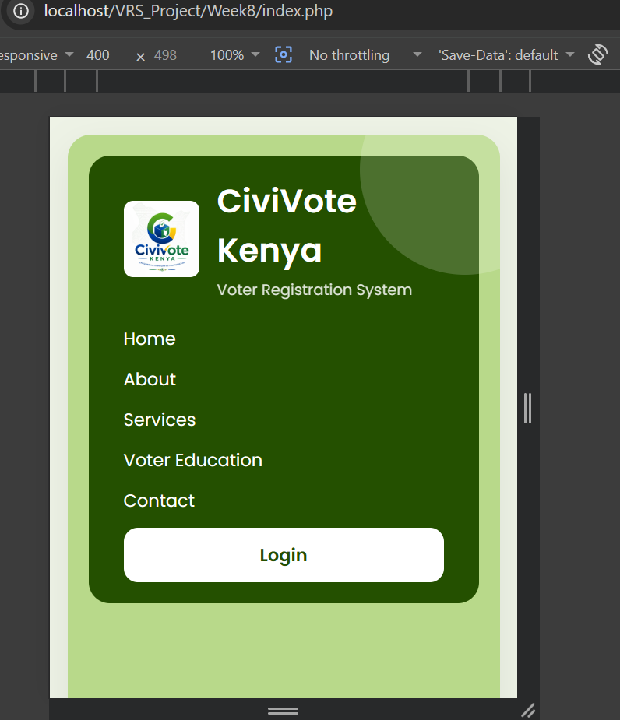
Figure 45: Mobile view showing the responsive navigation and layout.
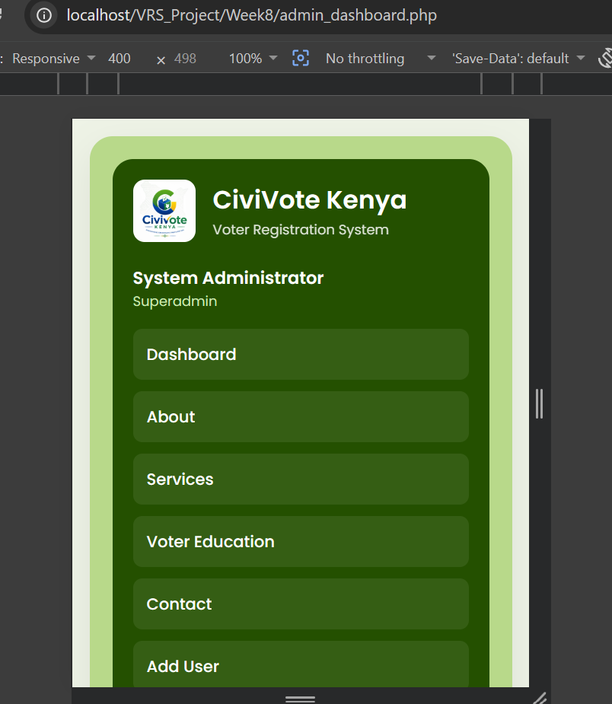
Figure 46: Responsive navigation menu displayed on a mobile device.

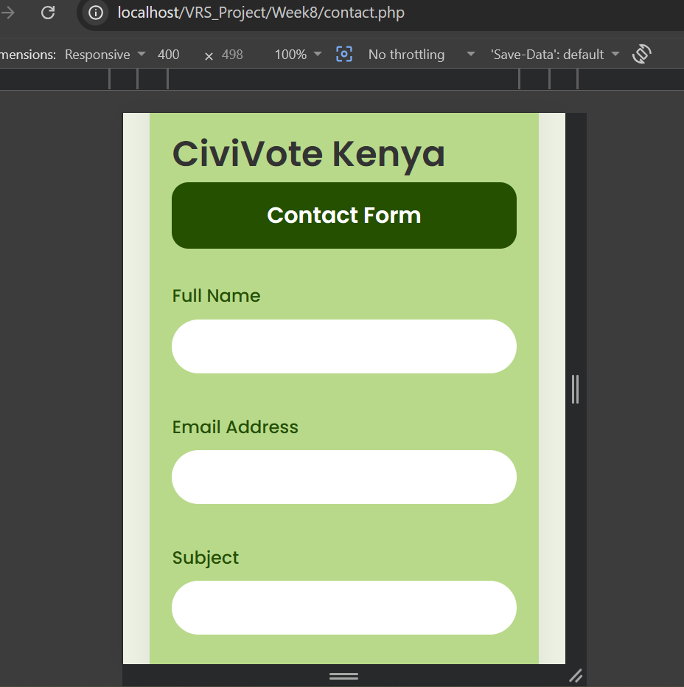
Figure 47: Responsive contact form adapted for smaller screen sizes.

8.2 Extra Practice Assignment
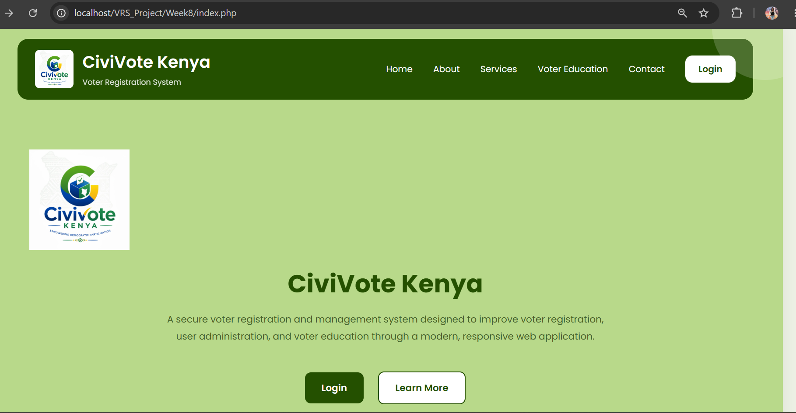
Figure 48: Home page of the CiviVote Kenya website.

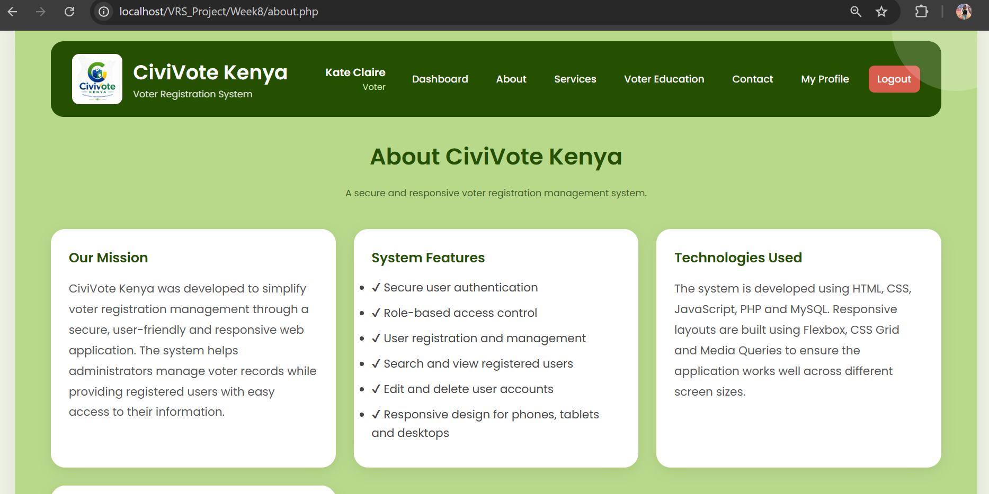
Figure 49: About Us page describing the CiviVote Kenya system.

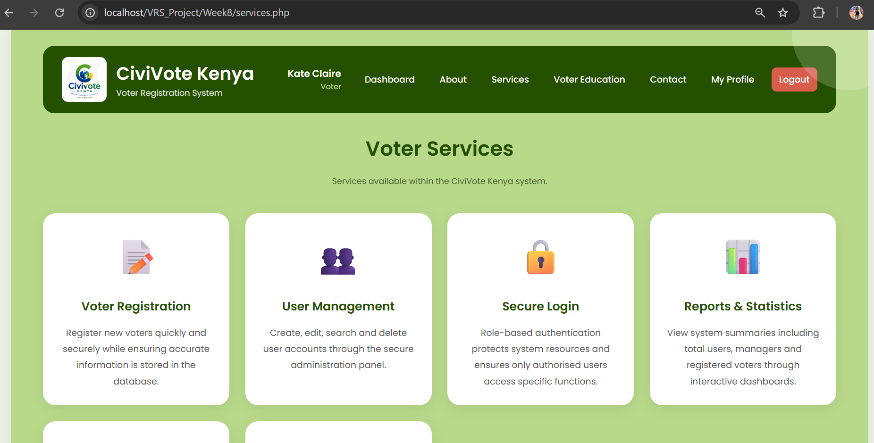
Figure 50: Services page outlining the services offered by the CiviVote Kenya system.
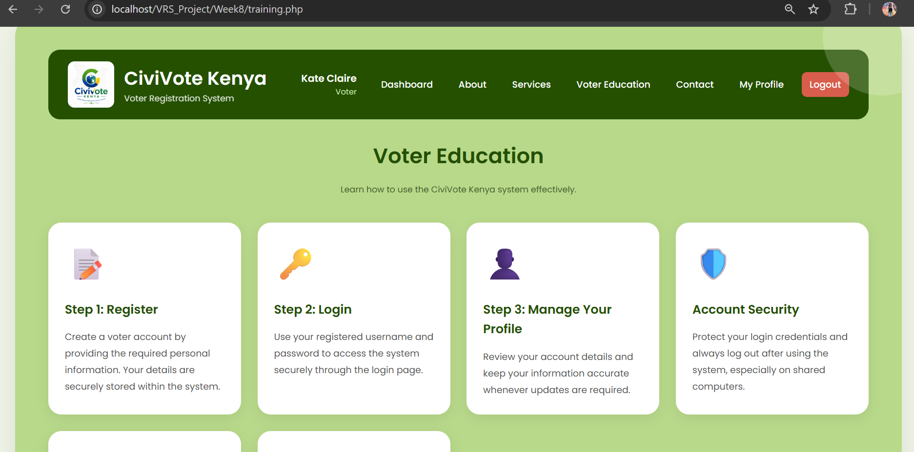
Figure 51: Voter Education page providing guidance to users.

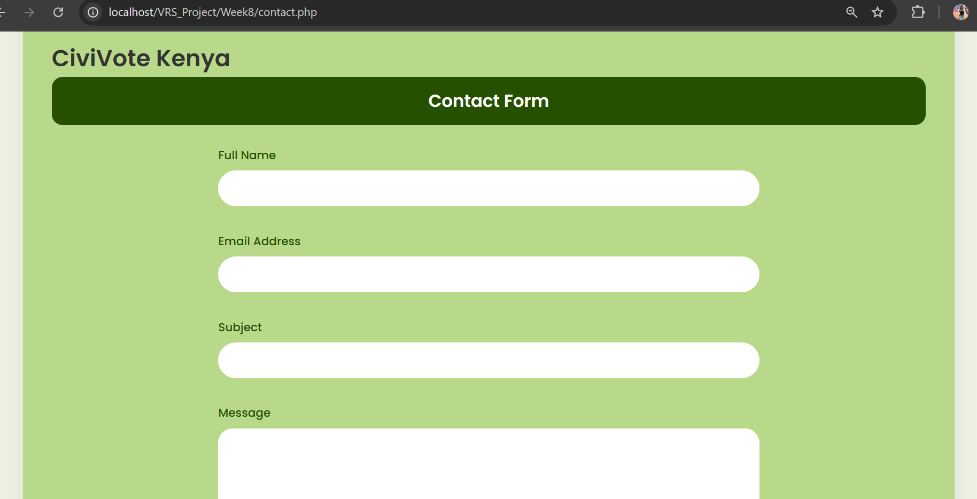
Figure 52: Contact page allowing users to submit enquiries.

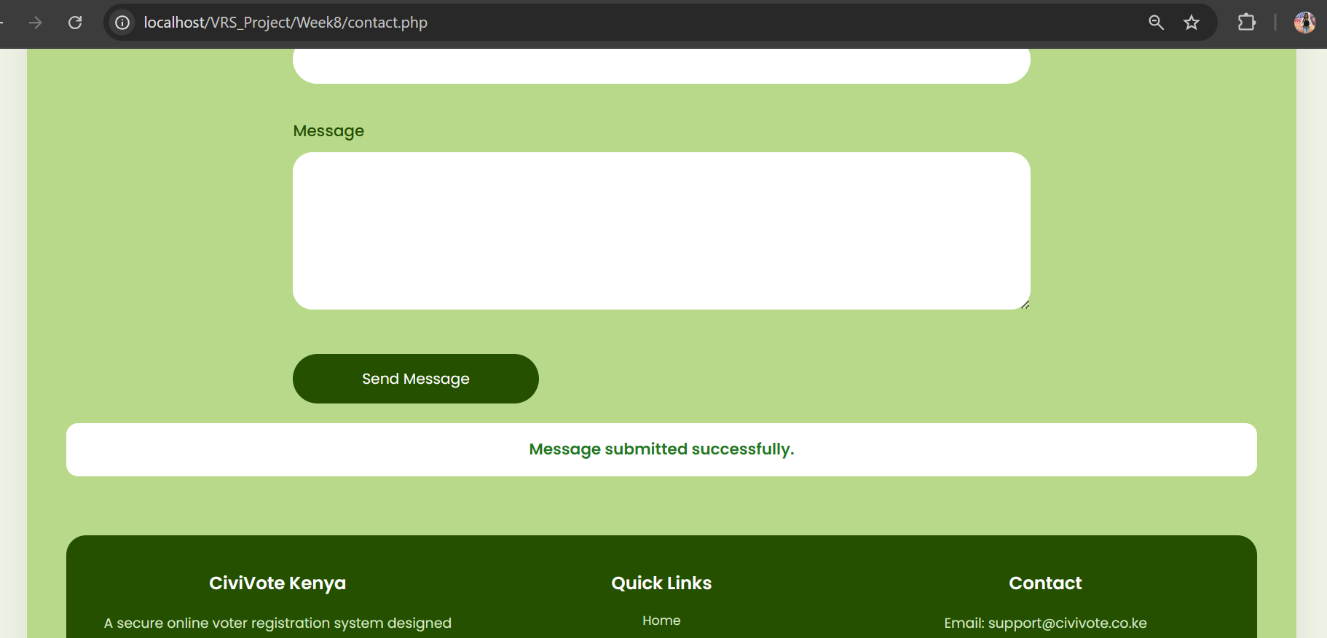
Figure 53: Successful submission of the contact form.

